Weapons, statues and museum collections in Iraq
Morgan Meyer - October 2003
www.vgpolitics.f9.co.uk/031201.doc

It seems that there are three kinds of objects in Iraq. Omnipresent in the news are objects to be found, objects to be destroyed and objects to be preserved.
1. Weapons of mass destruction have to be found. We are said that they do exist, that they will be found and destroyed. I do not wish to enter the debate of whether or not those weapons exist. Instead, I am interested in how they are made to exist. Politicians talk about them and provide us with evidence of their existence. The weapons are reified: an abstraction is treated as substantially existing, or as a concrete material object. They are ‘made into a thing’ whether or not they really exist. If they do not physically exist, they nevertheless exist as a cause that led to war. And they exist as traces: a mobile laboratory inside a truck is an indication, we are said, that they do exist. And what seems sure is that they existed: they have been used in the past. Nevertheless, not all weapons of mass destructions have to be destroyed (as shows the following humoristic illustration).

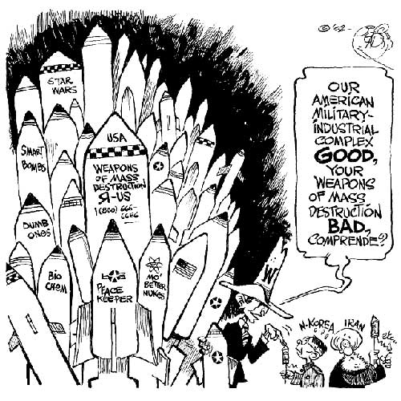
To understand this situation, we have to be able of - what George Orwell calls – ‘double-thinking’.
2. Objects to be destroyed are the statues of Saddam Hussein. Why this is so is straightforward. In order to change a regime you have to change and get rid of persons, systems, images, objects that support the regime to be overthrown. As the statues of Hussein are the very symbol of his power, presence, and regime they are destroyed. The destruction of these images is an ‘iconoclasm’. “’Iconoclasm’ is when an image or a representation is smashed to pieces. There might be many reasons for such an act. It might be to get rid of something that is an offence to one’s values, to give way to some other greater and better image, or perhaps to dispense entirely with any form of representation. For many people »iconoclasm« is a curse, what people usually assume that »vandals«, »heretics«, »madmen« or »barbarians« do. But for others to be an »iconoclast« is a virtue, the proof of his or her ability to resist authority, to show critical acumen, to break radically with the past” (Latour).
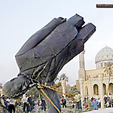
However, there are reasons for not destroying these statues. In the future, these statues, like the concentration camps of World War II, like the Berlin Wall, will be testimonies of the past. Understanding these objects and seeing them is essential. Those objects are important, for example, to prevent racists like Jean-Marie Le Pen saying that the concentration camps were ‘details’ (or maybe people like Silvio Berlusconi to say that Mussolini did not kill anyone) or some people deny their sheer existence. They are objects that prevent too much historical revisionism. To sum up, the statues have to be destroyed and have to be preserved at the same time. So instead of talking about ‘iconoclasm’, we should talk about ‘iconoclash’: “’icono-clash’ is when there is a deep and disturbing uncertainty about the role, power, status, danger, violence of an image or a given representation; when one does not know whether an image should be broken or restored; when one no longer knows ... if the image-worshipper is a pious bigot or a respectable devout, or if the image-maker is a devious faker or a clever fact-maker and truth-seeker” (Latour).
3. Objects to be preserved are - amongst others - the Iraqi National Museum’s collections. Like the statues, they are testimonies of the past. But unlike these, they are the evidence of a ‘good’ and very valuable past. They contain the world's oldest art, human's earliest writing, catalogued and excavated in the river valleys where civilization began. When we see images of empty display cases and great disorder, there is a sense of loss (and we understand why the museum director holds his head in his hands).
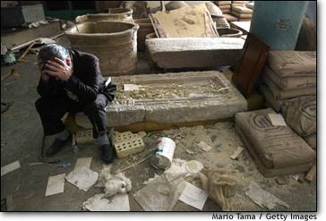

Disorder is in contradiction to the definition of a museum. A museum is a very ordered space, from an architectural and discursive point of view (Hetherington). From the way it is build, ordered and protected a museum can be compared to a fortress. (At some point during the war, the museum was a fortress in two senses. It housed and protected the museum’s collection and it was also used for military purposes, to protect Iraqis from attack.) When this fortress is stormed, and when museum objects are stolen, we realise what is lost with those objects and why it is important to protect them.
***
What we can see, in these three examples, is the relational aspects of objects. Objects have meanings because they are related to other things. Weapons are related to danger and death. Statues are related to a regime. Museum collections are related to a valuated past. This shows why it makes sense to talk of the ‘social life of things’ (Appadurai).

Referenced texts
Appadurai, Arjun (ed) (1986) The Social Life of Things, Cambridge University Press
Hetherington, Kevin (1996) “The utopics of social ordering: Stonehenge as a museum without walls”, in Macdonald, Sharon and Gordon Fyfe (eds.) Theorizing Museums, pp.153-176, Oxford: Blackwell
Latour, Bruno (2002) “What is Iconoclash?” in Iconoclash, http://www.iconoclash.de
Orwell, George (1950) 1984, Paris: Gallimard

SEND LETTERS OR ENQUIRIES ON THIS ARTICLE TO: vanguardonline@hotmail.com

